ISM 6
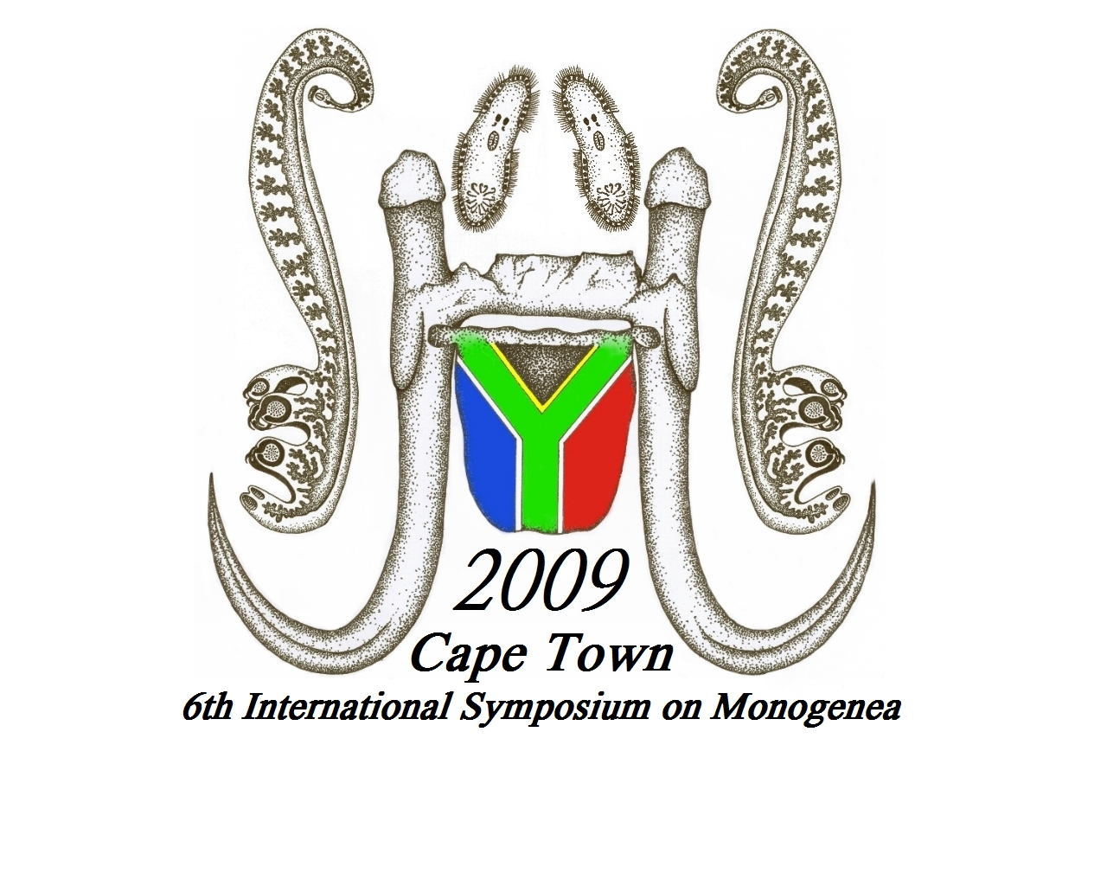

TRAVEL ITINERARY

Cape Town International airport is about 30 minutes drive from the symposium venue. A shuttle service will be available to collect delegates from the Cape Town International Airport and deliver them to their respective hotels. At the airports, conference staff will be visible, wearing the ISM6 branded T-shirts, so look out for them. The shuttle service will transfer delegates back to Cape Town International Airport after the conference.
Name:
Other people in group:
Date of arrival in Cape Town:
Airline and Flight Number:
Time of arrival:
Date of departure from Cape Town:
Airline and Flight Number:
Time of departure:
Hotel where you made a reservation:
Do you whish to make use of the ISM airport shuttle?

Please fax this form to +27 21 434 2144
or email it to david.vaughan@aquarium.co.za

