Second circular– ISM6

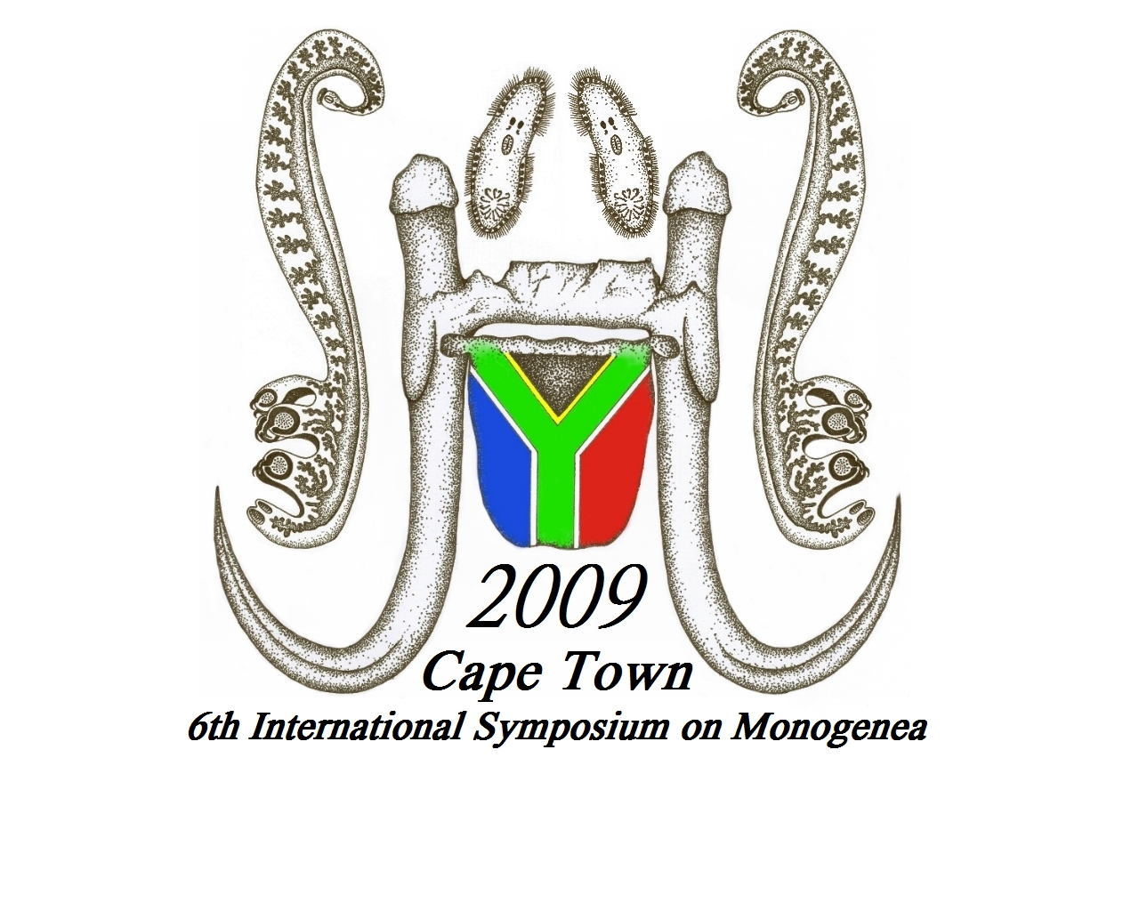
6th International Symposium on
Monogenea

3-7 August 2009

Protea Hotel Victoria Junction

Cape Town

South Africa

A. SCIENTIFIC COMMITTEE
Ian Whittington (Chairman)
Louis du Preez (Organiser)
Kevin Christison (Organiser)
Susan Lim
Claudia Santos
Andy Shinn
Olivier Verneau

B. VENUE
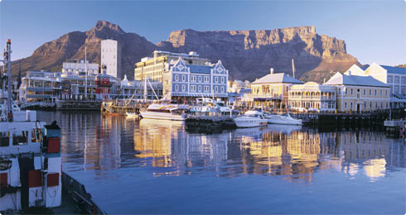

Situated between Robben Island and Table Mountain in the heart of Cape Town's working harbour, the V&A Waterfront has become South Africa's most visited destination. Set against a backdrop of magnificent sea and mountain views, exciting shopping and entertainment venues are intermingled with imaginative office locations, world-class hotels and luxury apartments in the residential marina. The 6th International Symposium on Monogenea will take place at the Protea Hotel Victoria Junction which is located in Greenpoint, merely 1km (5 minute walk) from the V&A Waterfront and other attractions that make Cape Town one of the world’s most exciting and beautiful destinations.

C. PRELIMINARY PROGRAM
Sun 2 August 2009 | 15h00 – 19h00 Registration  19h00 Icebreaker at Two Oceans Aquarium
Mon 3 August 2009 | 8h00-13h00 Session 1 with tea break  13h00-14h00 Lunch  14h00-16h00 Session 2 with tea break  17h00 Free evening
Tues 4 August 2009 | 8h00-13h00 Session 3 with tea break  13h00-14h00 Lunch  14h00-16h00 Session 4 with tea break  17h00 Social evening (see below)
Wed 5 August 2009 | 8h00-17h00 Mid symposium tour
Thurs 6 August 2009 | 8h00-13h00 Session 5 with tea break  13h00-14h00 Lunch  14h00-17h00 Session 6 with tea break  17h00-1730 Bid Presentations for ISM7  18h00 Free evening
Fri 7 August 2009 | 8h00-13h00 Session 7 with tea break  13h00-14h00 Lunch  14h00-16h00 Session8  16h00 Busses leave for Moyo Restaurant  18h00 Banquet at Moyo Restaurant

D. SCIENTIFIC PROGRAM
Presently, 8 scientific sessions are planned with five keynote addresses by invited speakers of international acclaim. The emphasis of ISM 6 clearly remains on the Monogenea. A wide range of themes in parasitology will be addressed including parasitology in Africa.

Session 1 Phylogeny
Session 2 Taxonomy, Morphology and Biodiversity
Session 3 Evolutionary biology and Ecology
Session 4 Host-Parasite relationships
Session 5 Host-specificity
Session 6 Gyrodactylid biology
Session 7 Aquaculture and monogeneans
Session 8 The way forward

E. ABSTRACTS
Complete your abstract according to the sample abstract available on the conference web page (http://www.gyrodb.net/ISM6.php) and email to Louis.duPreez@nwu.ac.za before the deadline of 31 May 2009.

F. REGISTRATION FEE
Due to the fluctuation in the South African Rand the organisers have converted the registration fee to the equivalent amount in Euro at the time of the first circular.

FULL PARTICIPANT | 220 Euro | For full duration – Includes Welcoming Function, Conference Banquet, daily lunch, tea/ coffee/refreshments, programme, abstracts, conference bag, name tag
STUDENT REGISTRATION FEE | 130 Euro | For full duration – includes above items for full participant
ACCOMPANYING PERSON FEE | 130 Euro | For full duration – includes Welcoming Function, entry to all Conference venues, Conference Banquet, daily lunch, tea/ coffee/refreshments, daily excursions.
LATE REGISTRATION FEE | 300 Euro | Registration after June 2009 (including students)

G. ACCOMMODATION
We have decided to host the symposium in the Protea Hotel Victoria Junction hotel in Greenpoint close to the Waterfront and negotiated a price of R900 per single room or R1285.00 (sharing) for accommodation and breakfast. Please make your own reservation by visiting the hotel website at http://www.proteahotels.com/protea-hotel-victoria-junction.html Make sure to mention in the “Questions or comments” section that you are with ISM6. We encourage everyone to stay in this hotel but if students would prefer to book in backpacker type accommodation we recommend a venue close to the waterfront. Like in any big city it is not safe to wander alone at night. http://www.wheretostay.co.za/wc/cm/accommodation/green-point.php
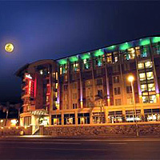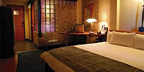

H. SOCIAL PROGRAMME
Sun 2 August | Arrival and early registration  Meet and Greet at Two Oceans Aquarium in the Victoria & Alfred Waterfront
Mon 3 August 2009 | Free night. Informal arrangements.
Tues 4 August 2009 | “Spirit of Africa” Enjoy South African food, wine and music at the Victoria Junction.
Wed 5 August 2009 | Full day mid symposium tour. We will drive along the spectacular coast to the famous whale watching town of Hermanus and visit an abalone aquaculture farm on the way.
Thurs 6 August 2009 | Free night. Informal arrangements.
Fri 7 August 2009 | Symposium closure and banquet.

I. CLIMATE
The winter months in Cape Town (June – August) are characterised by short days with late sunrises and early sunsets. The weather conditions range from dry and warm to wet and cold. Temperatures at this time of year generally range from 2 – 20 ºC. Come prepared for all weather conditions.

J. HEALTH RISKS
When it comes to health in Cape Town, tourists can be assured that no health risks exist and that there is no need for a tourist to be vaccinated before entering South Africa. It is however advised for all tourists to take out medical insurance, not only when visiting South Africa but for other destinations as well. Cape Town is clean and safe and the tap water of South Africa is safe to drink, unless otherwise stated. Visitors to South Africa may be sensitive to the strong South African sun and therefore a good sunscreen must be applied for skin protection. It is not required for tourists in Cape Town to bring any non-prescribed drugs as the pharmacies of South Africa are stocked with local and international branded medicines. Staffing of pharmacies is by highly qualified pharmacists.
For those of you who plan to travel to for example Kruger Park Malaria prophylaxis is recommended, although it is low risk season.
Overindulgence in South African beer and wine may be a health risk.

K. TRAVEL ARRANGEMENTS
Several airlines offer direct flights from major hubs to Cape Town. Alternatively, the flight may stop over in Johannesburg International airport. We suggest that you arrive on 2 August. The venue is about 30 minutes from Cape Town International Airport. In July we will ask you for your travel itinerary in order to arrange for airport pick ups that will take you straight to your accommodation.

L. ORGANISING COMMITTEE
Convenors | Louis du Preez & Kevin Christison | Louis.duPreez@nwu.ac.za & kchris@deat.gov.za
Secretary & finances | Carina de Beer | Carina.deBeer@nwu.ac.za
Other | Che Weldon
Other | Leon Meyer
Local Transport | David Vaughan

M. IMPORTANT DATES
Registration deadline | 31 May 2009
Deadline for submission of abstracts | 31 May 2009
Final circular | July 2009

